**Walkthrough – NullByte 1**

Contents

Host Discovery 2

Nmap 2

Nikto 2

Dirb 3

Exiftool 3

Viewing Website 3

Hydra 3

SQLMap 3

Hashes.com 5

SSH 5

Exploitation 5

Searching for Binaries 5

Flag 6

# Host Discovery

**Victim**: 192.168.56.139/24

**Kali**: 192.168.56.101/24

# Nmap



# Nikto





# Dirb

# Exiftool

Looking at the image you can download it. I will also used this tool to determine if the meta data contains anything important.



P-): kzMb5nVYJw

# Viewing Website

Secret Directory

Login Page for Database.

Default

Viewing the Secret Directory source code I can see this hint.

# Hydra

hydra -l none -P /usr/share/wordlists/rockyou.txt 192.168.56.139 http-post-form "/kzMb5nVYJw/index.php:key=^PASS^:invalid key"

I got ‘key’ attributed from the source code of website and I got index.php from incorrectly typing in the key.

# SQLMap

**URL**: <http://192.168.56.139/kzMb5nVYJw/420search.php?usrtosearch=a>

Once I got the key, I then proceeded to type a random search value ‘a’ and look at the url. I then then read the message that stated it was ‘fetching data’. This is an indicator that databases are at work.

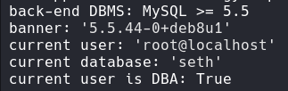



This command will retrieve the data from the database mysql and from table user.



Then to make the data readable I used the above command.

**Credential Information**:

PhpMyAdmin: sunnyvale

Root: Sunnyvale



**Hash**: YzZkNmJkN2ViZjgwNmY0M2M3NmFjYzM2ODE3MDNiODE

# Hashes.com

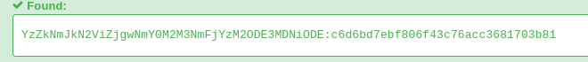

After doing it twice, I found the hash value for the account Ramses: omega

# SSH





Given the credentials ramses:omega I was able to get into the ssh service on port 777.

# Exploitation

I begin my checking if I can sudo on behalf of someone or without a password.

## Searching for Binaries

I then looked for the possible binaries. I found poolkit.

https://www.exploit-db.com/exploits/50689

I created the ‘c’ files and then created a python server.

After they were downloaded in the victim’s /tmp directory I went to work giving the makefile execution privileges.



Then calling make.

Once the code ran, the binary was ready.

Then executed ‘./exploit’.

I am now root.

# Flag

In the root directory I was able to get the flag called ‘proof.txt’.